Pershing School 2019-2020 Student Technology Guide

Introduction
This manual will serve as an instructional resource for students seeking information about, or experiencing issues with their student devices. Please consult this guide first if you have any questions related to your device.
Expectations
Students are expected to arrive to school daily with their school issued laptop and charger. The laptop should be fully charged upon the start of the school day. Students are expected to be cautious and considerate with the use of their digital device. Students are responsible for the care and use of their digital device.
Device Rules
- When not in use, laptops are to be kept in backpacks.
- Students are only allowed to access websites and applications assigned by teachers or OCPS for instructional purposes.
- Laptops must be kept in backpacks while transitioning between classes.
- Only school issued stickers or decals are allowed on your school issued device. Writing on a device with a marker or placing personal stickers directly on a device may be considered vandalism or property destruction and may result in school discipline and technology fines.
- Laptops must be put completely away while inside the cafeteria.

Proper Care of Your Device
- Take precaution when setting the device down, even when the device is in your backpack. Do not throw or drop your backpack. A hard hit on a solid surface can cause internal and/or external damage to the device.
- Store your laptop and charger at home away from pets and/or young children.
- Practice good online safety to keep your device free of viruses or malware.
- Devices should be unplugged from the charger when placed in backpacks.
- Backpacks and Laptops should be kept in a clean, dry place.
- Keep the device away from containers holding any food items or liquids.

Keep in mind that your student device is loaned to you by OCPS. Therefore, it is your responsibility to keep it in good condition. This includes keeping your laptop free of cracks, dents, dirt, crumbs, malware, etc. If your laptop is physically damaged, please see the “Damage to Your Student Device” section for more information.

Reporting an Issue & Receiving Technical Assistance
- Students must obtain a tech slip from their teacher to go straight to the media center prior to going to the cafeteria for lunch. Students may also visit the Media Center between 8:15 – 8:45 to receive assistance
- Students will report to the technical support staff member on duty at the circulation desk
- Students must report back to the Media Center before the end of their lunch or before 8:45 if visiting in the morning to retrieve their digital device or discuss next steps.

Note: You must bring the following items with you to the Media Center for assistance:
- Laptop
- Laptop charger
- Completed Tech Slip

Damage to Your Student Device
If your student device is physically damaged in any way (Example: cracked case/screen, missing keyboard keys), you will need to return this device to the school. You may be issued a temporary replacement device while your issued device is serviced..
Note: Damage may incur a fine.

Follow these instructions for damaged device issues:

- Students must obtain a tech slip from their teacher to go straight to the media center prior to going to the cafeteria for lunch, or before school.
- Students will report to the technical support staff member on duty in the media center.
- Students must complete a witness statement detailing the damage of their digital device.
- Students must report back to the media near the end of their lunch or before 8:45 if visiting in the morning to retrieve their new digital device or discuss next steps.
- If your laptop is damaged or requires further technical support you will be asked to submit a Student Tech Request at the kiosk.
Note: Students may return to class with a temporary replacement device if more time is needed to investigate or repair the device as long as a replacement device is available.

Student Tech Request Form
In the Student Tech Request form, choose from the following options in the “Issue Type” drop-down:
- Battery: Your laptop cannot charge, does not hold a charge, or gives a battery error message.
- Charger: Your charger does not charge any laptops.
- Computer Slow: Your computer is running slowly (e.g. typing delays, lagging cursor).
- Physical Damage to Device: Damage to your laptop’s screen has resulted in visible cracks.
- Device Login Issue: You cannot log into your laptop (e.g. you receive a “No logon servers available,” or “Account has been disabled” message).
- Google: You are receiving error messages or other issues related to Google.
- Hardware Issue: Your problem does not fit any other category.
- Keyboard: Your keyboard is not functioning normally (e.g. problems with typing).
- Missing Keys: One or more keys have popped off your laptop’s keyboard.
- Sound: No sound plays through your laptop’s speakers or the sound is distorted.
- Touchpad/Mouse: Your touchpad on the device does not respond to clicks.
- Touchscreen: Your touchscreen does not respond to tapping and pressing.
- WiFi: You are experiencing issues with connecting to the Internet and/or OCPS Wi-Fi.
- iOS App Install, LanSchool Install, LaunchPad Issue, Microsoft Office Install, Smart Notebook Install: These options are self-explanatory and are rarely chosen by students. However, if you believe you are experiencing issues related to any of these services, select the most relevant option.

Setting Up Your Account

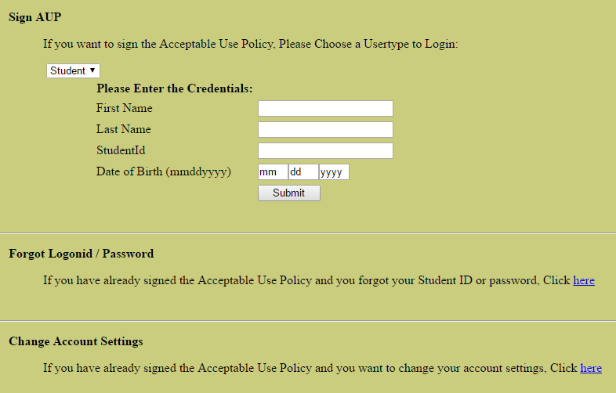

To set up your student account for the first time, log in to a computer on campus using the following credentials:
Username: studentid
Password: studentid
Next, fill out the fields in the Sign AUP section, as seen in the image above, with your personal information. Click “Submit”, then follow the on-screen instructions to set up your student account.

Changing Your Password
To change your password at any time after creating your student account, navigate to studentid.ocps.net on an OCPS device and click the link under the Forgot Login ID / Password section. Then follow the on-screen instructions to reset your password.

Note: Always use a strong password. You are required by OCPS to use uppercase and lowercase letters (which may stand for a word, phrase, or name) and at least one number. Never include your name or birthdate or the word “password” in your password.

Note: Please write your password down in a secure manner for future reference. Always keep your password safe by never sharing it with other students.

Hardware
In this section, you will find a list of the most common hardware issues associated with your student device. The majority of hardware issues result in laptop replacement. If you believe that an unfixable issue has occurred, check this guide to confirm the problem. If your problem matches an issue in this guide please follow the procedures outlined for Reporting an Issue & Receiving Technical Assistance and Damage to Your Student Device.

Whenever the phrase “hard reset” is used during troubleshooting, it refers to holding the physical power button on your student device for five full seconds to turn the device off, waiting for five more seconds, then pressing it once to turn it back on. A hard reset can frequently fix basic issues that you may be experiencing.

Touchscreen
Students experiencing issues with their device’s screen should refer to the following section for assistance.

Black Screen or Dark Sections
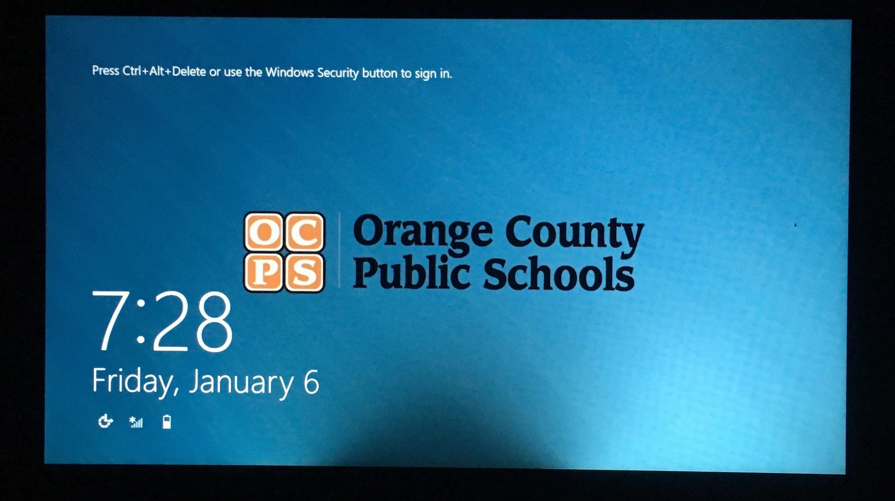
If your laptop has a black screen, or dark patches on the screen, diagnose this problem as follows:
- Connect the laptop to a charger to ensure that the issue is unrelated to the device’s battery being depleted or malfunctioning.
- Perform a hard reset on the device. This will eliminate the possibility of the issue being software-related.
- Look at the power button; if it is lit up, indicating that the laptop is on, but the screen is still completely dark, the laptop likely has a black screen issue. Confirm this by pressing the Caps Lock button once. If the button lights up but the screen is still dark, the laptop has a black screen issue and must be replaced.
- If the screen is not completely dark (e.g. it has patches or areas in which the screen is darker), it must be replaced.
- Visit the Media Center if your laptop has a black screen, as the device must be replaced.

Unresponsive to Touch
If you are unable to use the laptop touchscreen, try the following:
- Perform a hard reset on the device.
If the touchscreen is still not working, visit the Media Center and fill out a student tech request to have your laptop replaced.

Wireless Adapter
The wireless adapter enables your laptop to connect to the Internet via Wi-Fi. If you are experiencing issues connecting to the school network or accessing websites, refer to this section.

Internet Connectivity

If you cannot access websites or connect to the Internet, try the following steps:
- Press the “Function” and “Home” keys on your keyboard to make sure the laptop’s antenna is on and able to receive a Wi-Fi signal.
- Save work in any other programs and then perform a hard reset on the device.
- Right-click the icon at the bottom right hand corner of the screen and select “Troubleshoot problems.”
- If you are prompted to insert a network cable, select “Skip this step."
- A window will pop up, displaying the problem that the laptop is having. If there are any errors with red X’s and circles next to them, or if running the diagnostic tool did not fix the problem, you will need to visit the Media Center so that your laptop can be examined.

“No logon servers available” Message
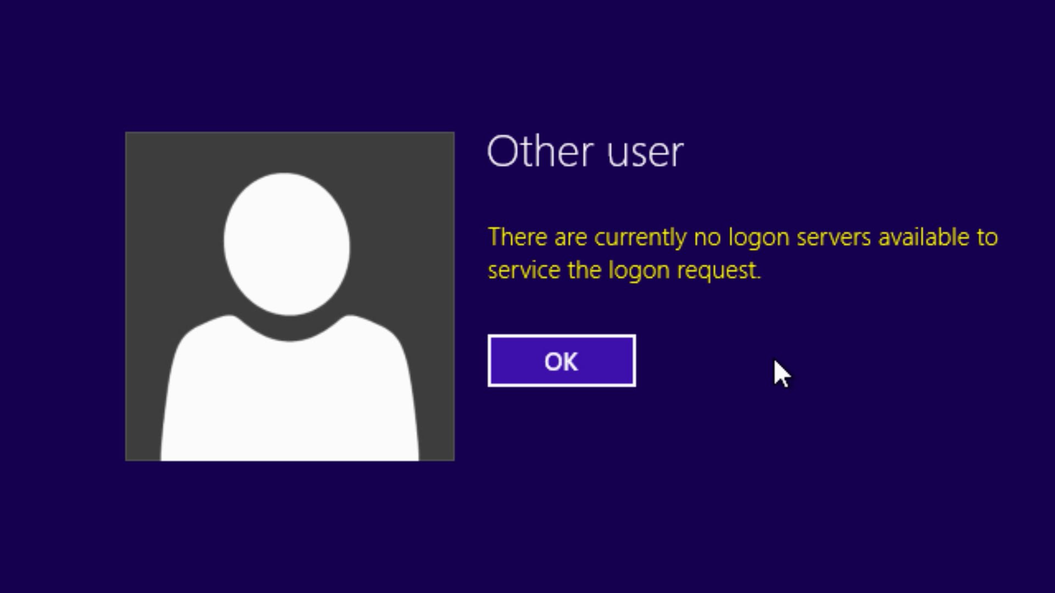
When attempting to log in to your student device, you may encounter a message that includes “No logon servers available,” which prevents you from logging in. Address this problem by performing the following actions:
- Perform a hard reset on the device. Once it starts up, try to log in again.
- If you still cannot log in to your device, press the “Function” and Home” buttons at the same time to turn your antenna off. Wait ten seconds, then press the press the “Function” and “Home” buttons again to turn the antenna back on. If the laptop still displays a “No logon servers available” message, you will need to visit the Media Center for assistance.

Battery
If your device’s battery is dead despite charging it for a long period of time, or if your device is not charging when plugged in, try the following steps:
- Plug the charger into a different power outlet.
- Use a different charger to determine if your charger is damaged. If your charger is the cause of the problem, you can replace it by visiting the Media Center.
- Turn on your laptop while it is plugged in. If you receive a message containing “Critical Battery Alert” the battery is malfunctioning and your laptop will need to be replaced. Visit the Media Center to fill out a student tech request and resolve the issue.

Login Errors
If you cannot log in to your OCPS account on any device for any reason - for example, you have forgotten your password, or the “Your account has been disabled” message appearing when attempting to log in - refer to the “Setting Up Your Account” section and follow the instructions to sign the AUP. If you continue to have issues, visit the Media Center for assistance.

Frequently Used Websites
Note: Sharing of files and folders should be strictly limited to instructional purposes only. Any students using their devices or school programs inappropriately may be subject to school discipline.

Google Suite
The Google Suite is a collection of tools that includes Drive, Classroom, and many more. Students and teachers most frequently use Google Docs, Slides, and Sheets for word processing, presentation creation, and data collection/analysis, respectively. Unlike the similar Microsoft Office programs - Word, PowerPoint, and Excel - Google tools are cloud-based, so documents created with the Google Suite are saved automatically and are stored online in Google Drive rather than on your computer.

Google Drive
Web address: drive.google.com
Drive is used to store files made with Google tools, such as Docs, Slides, etc. as well as personal files online, so that they can be accessed on any computer.

Finding Files
You can search for any file you have uploaded to the site or any document you have created with Google by entering its name in the search bar at the top of the page.

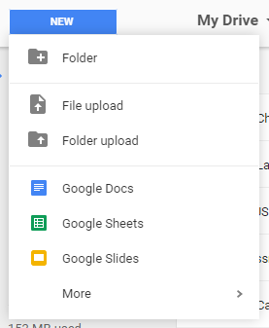
Create/Upload Files or Folders
Click on the large blue button marked “New” to bring up a menu with options for creating and uploading files or folders to Drive.

Sharing Files
There are multiple methods of sharing files in Google Drive, which allows other OCPS students to access a file in your Drive.
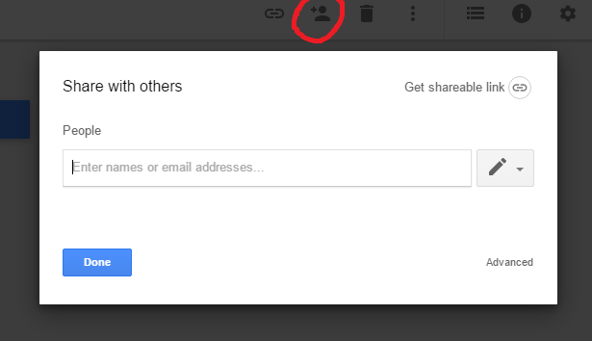
Share from Drive: In the main menu of Google Drive, you can right-click once on the file or folder you want to share, then click on the Share button. Enter the OCPS email addresses of the people you want to share the file with, then press the “Done” button when finished. The file or folder will then appear in the person’s “Shared with Me” section of Drive.

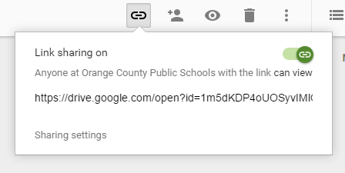
Link Sharing: You can also share files or folders by turning on Link Sharing, a feature that creates a link to the item. To enable this feature, select the file or folder you want to share, then click the icon that looks like a chain link. Click on the gray switch in the upper right hand corner of the white pop-up to enable Link Sharing; it will turn green once it is on. The link that appears can then be sent to anyone with an OCPS Google account.

Share from within the Document Itself: Click the blue Share button on the top right of your tool bar. Prior to sharing, the box will have a padlock next to the word Share. Once you have shared a document, the image will change to a document with a link underneath it. After selecting the Share button, you will have the option to copy a link or share with select people through email. You will also have the option to determine whether collaborators can edit, comment, or simply view the document.

For more information about sharing files and folders, visit the following Drive Help link.

Google Drive Issues
If you cannot access your Google Drive, verify that you are logged in with your OCPS Google account and connected to the internet. If you cannot log in to Google Drive, refer to section on Changing Your Password as a password reset will ensure that your Google account has the correct password.

LaunchPad
Web Address: launch.ocps.net
LaunchPad is a site from which you can access numerous school resources, including Khan Academy, Canvas and various online textbooks (if any are used by your teacher).

Logging In
Log into LaunchPad using your student ID and the password you use to log into your computer.

My Apps
The “My Apps” area contains links to the school resources described above. Click on the “My Apps” button on the bottom of the window to access it. If you are looking for a specific resource, use the search feature in the upper right corner of the page.

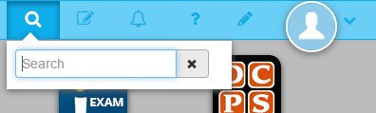

Accessing Textbooks
Each class has their own method of accessing online textbooks. Ask your teacher for information regarding your particular class.

My Files
The “My Files” area can be used to store files online and can be connected to Google Drive. Click on the “My Files” button at the bottom of the window to access it. By selecting “Manage Services,” you can link your Google account to Launchpad.

Skyward
Skyward Family Access will replace Progress Book Parent Access this year.
Skyward Family Access is the site on which you can find your schedule and all grades you have received during the school year

Logging In
Parents and students can login to Skyward Family Access through Launchpad.

Keyboard Shortcuts
The following are some keyboard shortcuts that students may find useful. When using these shortcuts, keep in mind that you must hold down all of the given keys simultaneously. Not all shortcuts will work in every program or website, but most will work in the Google Suite, Chrome, and Windows Explorer.

Action | Keystroke
Bold | Ctrl+B
Close Tab | Ctrl+W
Switch between tabs in browser | Ctrl+Tab
Copy | Ctrl+C
Paste | Ctrl+V
Cut | Ctrl+X
Find | Ctrl+F
Italics | Ctrl+I
New tab | Ctrl+T
New window | Ctrl+N
New folder | Ctrl+Shift+N
Open | Ctrl+O
Document outlines | Ctrl+Alt+A  Ctrl+Alt+H
Left align text | Ctrl+L (Microsoft)  Ctrl+Shift+L (Google)
Right align text | Ctrl+R (Microsoft)  Ctrl+Shift+R (Google)
Center text | Ctrl+E (Microsoft)  Ctrl+Shift+E (Google)
Justify text | Ctrl+Shift+J (Google)
Bookmark | Ctrl+D
Indentation | Ctrl+[ (left)  Ctrl+] (right)
Superscript | Ctrl+.
Subscript | Ctrl+,
Increase font size | Ctrl+Shift+. (Google)
Decrease font size | Ctrl+Shift+, (Google)
Redo | Ctrl+Y
Reload | Ctrl+R
Select all | Ctrl+A
Underline | Ctrl+U
Undo | Ctrl+Z
Zoom In | Ctrl+(+)
Zoom Out | Ctrl+(-)
Switch between apps | Alt+Tab
Restore recently closed tab in browser | Ctrl+Shift+Tab
Minimize Page | Windows Key+M
Show desktop | Windows Key+<
Lock the device | Windows Key+ L
Open settings | Windows Key+I
Screenshot entire screen | Windows Key+PrtSc

